**Flow Control**

If statements can be used to test one or more conditions and perform actions based on the results. Python syntax for flow control statements include ending the condition line with a colon and all code that is executed as a result of the flow control statement is indented once. Example:

if <test_condition>:

code block line 1

code block line 2

etc….

elif <test_condition:

code block line 1

else:

code block line 1

Now let's create a python script that uses an if statement to manage flow control.

1. Login into the python server.
2. Activate your python virtual environment and navigate to your Documents directory.
3. Open a file called flow.py in vim.
4. Add comment lines with your name and date.
5. Copy and paste the following code into your terminal. **NOTE: the indented code blocks beneath "if" and "else" may not indent when copied. You will have to go to these lines and indent them.**

# Modules are collections of functions  
# used to accomplish a particular task. They  
# can be loaded and reused in scripts.

# Modules are loaded with the import command  
# The os module contains a variety of functions  
# for working with an operating system

import os  
# A second way of loading a module using the from  
# keyword, which only loads the specified functions.  
# only import selected functions from module  
from colorama import Back, Fore, Style  
print(Fore.GREEN) # set font color to green  
  
# print the current working directory  
cwd = os.getcwd()  
usr = os.environ['USER'] # retrieve the current signed in user.

# Print a welcome message on two lines.  
# \n is a special character for line breaks.  
# the .format command can be used to pass variables into a print statement  
print('Hello {}!\nYour current path is {}'.format(usr, cwd))  
choice = input('List all files? (Y/N): ') # prompts user for choice  
if choice == 'Y':

print('\n')  
# the listdir function returns results as an array.  
# * unpacks them and sep='\n' adds a line feed after each one  
print(*os.listdir(cwd), sep='\n')

else:

print('Have a nice Day!')

# Reset print Styles  
print(Style.RESET_ALL)

1. Review the comments and ensure you understand them or ask for an explanation.
2. Test the code.
3. Insert a line after "print("Have a nice Day!')
4. Modify the script to ask if the user would like a listing of files from another directory.
   1. If yes, prompt for the full directory path and store that in a variable.
   2. Produce a file listing of the specified directory.
5. Submit a screenshot of your code and the executed result.
6. 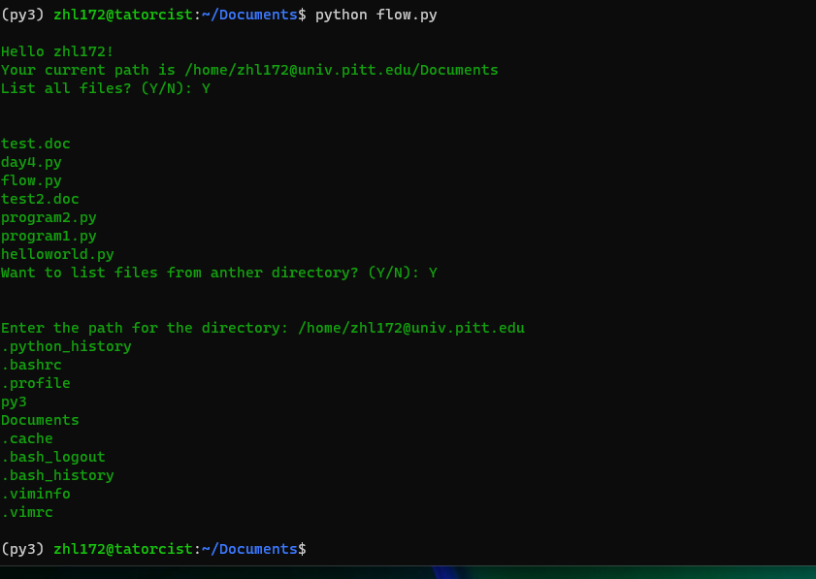
7. 